**Is not configured for a custom splash screen**

May 4, 2019 • Updated Sep 19, 2019

Appears in: [PWA audits](https://web.dev/lighthouse-pwa)

A custom splash screen makes your [Progressive Web App (PWA)](https://web.dev/discover-installable) feel more like an app built for that device. By default, when a user launches your PWA from the home screen, Android displays a white screen until the PWA is ready. The user may see this blank, white screen for up to 200 ms. By setting up a custom splash screen, you can show your users a custom background color and your PWA's icon, providing a branded, engaging experience.

**How the Lighthouse splash screen audit fails** [**#**](https://web.dev/splash-screen/?utm_source=lighthouse&utm_medium=devtools#how-the-lighthouse-splash-screen-audit-fails)

[Lighthouse](https://developers.google.com/web/tools/lighthouse/) flags pages that don't have a custom splash screen:

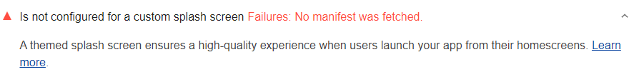

In the Lighthouse report UI the full PWA badge is given when you pass all of the audits in all of the PWA subcategories (**Fast and reliable**, **Installable**, and **PWA optimized**).

**How to create a custom splash screen** [**#**](https://web.dev/splash-screen/?utm_source=lighthouse&utm_medium=devtools#how-to-create-a-custom-splash-screen)

Chrome for Android automatically shows your custom splash screen as long as you meet the following requirements in your [web app manifest](https://web.dev/add-manifest):

* The name property is set to the name of your PWA.
* The background_color property is set to a valid CSS color value.
* The icons array specifies an icon that is at least 512x512 px.
* The specified icon exists and is a PNG.

# Use Custom Splash Screens

1. Last updated

Oct 23, 2020

1. [Edit](https://github.com/OutSystems/docs-product/blob/master/src/deliver-mobile/customize-mobile-app/use-custom-splash-screens.md)
2. [Download](https://success.outsystems.com/@api/deki/pages/20634/pdf/Use%2bCustom%2bSplash%2bScreens.pdf?stylesheet=default)

Applies only to Mobile Apps

By default, mobile applications have a custom splash screen displaying the main color defined in the app creation wizard. This splash screen is displayed after the Operating System loads your app (black screen) and after the WebView finishes loading the content (white screen).

It is possible to change the look of your app even before it is fully loaded by customizing the native splash screen. This way you make sure that the end user has a fluid experience from the moment they open your app by replacing the black to white screen transition with an image of your choice.

## Before you start

To use a custom image as the native splash screen of your app, you need to create PNG versions of your custom image for **all** the [Android/iOS splash screen sizes](https://success.outsystems.com/Documentation/11/Delivering_Mobile_Apps/Customize_Your_Mobile_App/Use_Custom_Splash_Screens#devices-screen-sizes-and-densities).

## Customizing the native splash screen

To use a custom image as the native splash screen of your app:

1. Create a ZIP file containing all the PNG versions of your custom image for all the Android/iOS splash screen sizes.
2. In the Data tab of the main Module of your app, right-click the Resources folder and import the ZIP file as a Resource.

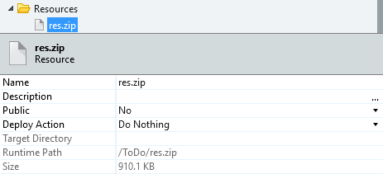

Leave the Deploy Action property as Do Nothing.

1. In the properties of the app module add the [Splash Screens JSON template](https://success.outsystems.com/Documentation/11/Delivering_Mobile_Apps/Customize_Your_Mobile_App/Use_Custom_Splash_Screens#splash-screens-json-templates) to the **Extensibility Configurations** property:

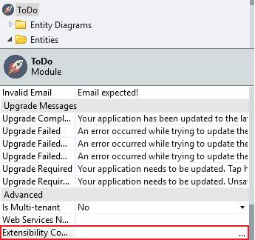

1. In the JSON template that you added to the **Extensibility Configurations** property, replace <path_to_resources_file> with the name of the ZIP file and replace each one of the <path_to_splash_screen_image>.png with the corresponding splash screen PNG image location inside the ZIP file. After this step, you should get a JSON similar to the following:

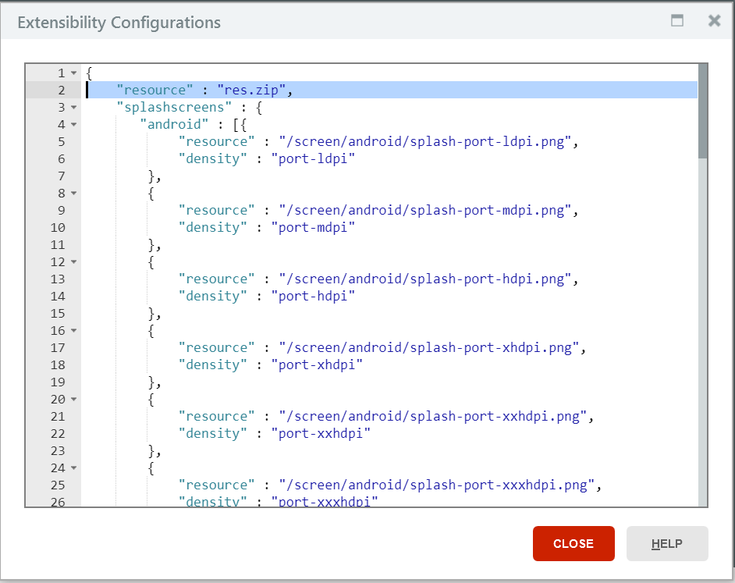

Ensure that you define the splash screen and the PNG image path for all sizes and densities available, otherwise, you'll get an error when generating your mobile application.

1. To make this change available to users, [publish and generate a new mobile application package](https://success.outsystems.com/Documentation/11/Delivering_Mobile_Apps/Generate_and_Distribute_Your_Mobile_App) and distribute it.

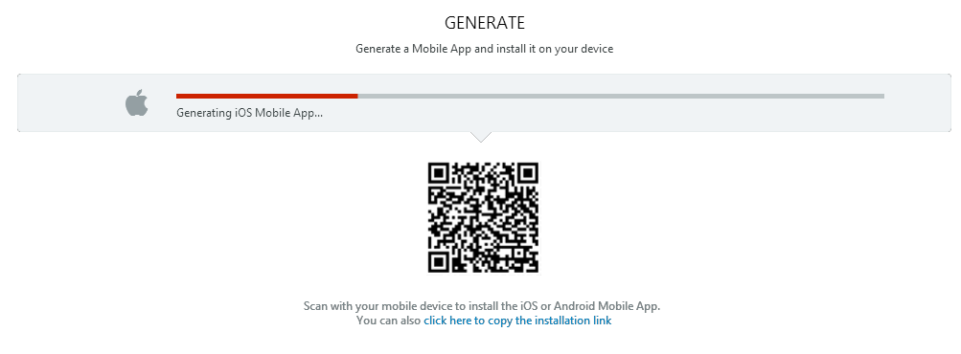

## Devices screen sizes and densities

### For Android

| **Width (px)** | **Height (px)** | **Density** |
| --- | --- | --- |
| 240 | 360 | port-ldpi (120 dpi) |
| 320 | 480 | port-mdpi (160 dpi) |
| 480 | 720 | port-hdpi (240 dpi) |
| 640 | 960 | port-xhdpi (320 dpi) |
| 960 | 1440 | port-xxhdpi (480 dpi) |
| 1280 | 1920 | port-xxxhdpi (640 dpi) |
| 360 | 240 | land-ldpi (120 dpi) |
| 480 | 320 | land-mdpi (160 dpi) |
| 720 | 480 | land-hdpi (240 dpi) |
| 960 | 640 | land-xhdpi (320 dpi) |
| 1440 | 960 | land-xxhdpi (480 dpi) |
| 1920 | 1280 | land-xxxhdpi (640 dpi) |

### For iOS

For iOS, the splash screen sizes depend on the [Mobile Apps Build Service (MABS) version](https://www.outsystems.com/goto/mabs) that you use to generate your mobile app packages.

#### MABS 4.0 or later

If you are using MABS 4.0 or later, you must use splash screen sizes [based in launch storyboard images](https://cordova.apache.org/docs/en/latest/reference/cordova-plugin-splashscreen/index.html#launch-storyboard-images).

| **Width (px)** | **Height (px)** | **Default Filename** |
| --- | --- | --- |
| 2732 | 2732 | Default@2x~universal~anyany |
| 1278 | 2732 | Default@2x~universal~comany |
| 1334 | 750 | Default@2x~universal~comcom |
| 2208 | 2208 | Default@3x~universal~anyany |
| 2208 | 1242 | Default@3x~universal~anycom |
| 1242 | 2208 | Default@3x~universal~comany |
| 1334 | 1334 | Default@2x~iphone~anyany |
| 750 | 1334 | Default@2x~iphone~comany |
| 1334 | 750 | Default@2x~iphone~comcom |
| 2208 | 2208 | Default@3x~iphone~anyany |
| 2208 | 1242 | Default@3x~iphone~anycom |
| 1242 | 2208 | Default@3x~iphone~comany |
| 2732 | 2732 | Default@2x~ipad~anyany |
| 1278 | 2732 | Default@2x~ipad~comany |

#### MABS 3.3

If you are using MABS 3.3, you must use splash screen sizes [based on the legacy launch images](https://cordova.apache.org/docs/en/latest/reference/cordova-plugin-splashscreen/index.html#legacy-launch-images).

| **Width (px)** | **Height (px)** | **Device** |
| --- | --- | --- |
| 320 | 480 | All non-retina iPhones and iPods |
| 640 | 960 | iPhone 4/4s (portrait) |
| 640 | 1136 | iPhone 5/5s/SE (portrait) |
| 750 | 1334 | iPhone 6/6s/7/8 (portrait) |
| 1242 | 2208 | iPhone 6+/6s+/7+/8+ (portrait) |
| 2208 | 1242 | iPhone 6+/6s+/7+/8+ (landscape) |
| 1125 | 2436 | iPhone X (portrait) |
| 2436 | 1125 | iPhone X (landscape) |
| 768 | 1024 | All non-retina iPads (portrait) |
| 1024 | 768 | All non-retina iPads (landscape) |
| 1536 | 2048 | All retina iPads (portrait) |
| 2048 | 1536 | All retina iPads (landscape) |

## Splash screens JSON Templates

Find below two templates that you can copy and paste to the **Extensibility Configurations** property of your module. Choose only one of them, depending on the [Mobile Apps Build Service (MABS) version](https://www.outsystems.com/goto/mabs) you are using to generate your mobile app packages, and copy the whole template. The templates include definitions for both Android and iOS.

* In each template, <path_to_resources_file> is the path to the ZIP file and each <path_to_splash_screen_image>.png is the path to the PNG version of your custom image specific to a certain splash screen size.
* The snippet inside the "splashscreens" tag defines the splash screen image location in the ZIP file for every splash screen size for both platforms ("android" and "ios").
* The last part of the template uses a "preferences" tag to set a preference, "SplashScreenDelay", that applies to both mobile platforms ("global" tag), and that displays the native splash screen for 3 seconds before automatically hiding it. To make sure the native splash screen is shown, you **must** define this preference since the default value for "SplashScreenDelay" is 0.

### JSON template for Android and iOS using MABS 4.0 or later

|  |  |
| --- | --- |
| 001 | { |
| 002 | "resource": "<path_to_resources_file>", | |

|  |  |  |
| --- | --- | --- |
| 003 | "splashscreens": { | |
| 004 | "android": [{ |

|  |  |  |
| --- | --- | --- |
| 005 | "resource": "<path_to_splash_screen_image>.png", | |
| 006 | "density": "port-ldpi" |

|  |  |  |
| --- | --- | --- |
| 007 | }, | |
| 008 | { |

|  |  |  |
| --- | --- | --- |
| 009 | "resource": "<path_to_splash_screen_image>.png", | |
| 010 | "density": "port-mdpi" |

|  |  |  |
| --- | --- | --- |
| 011 | }, | |
| 012 | { |

|  |  |  |
| --- | --- | --- |
| 013 | "resource": "<path_to_splash_screen_image>.png", | |
| 014 | "density": "port-hdpi" |

|  |  |  |
| --- | --- | --- |
| 015 | }, | |
| 016 | { |

|  |  |  |
| --- | --- | --- |
| 017 | "resource": "<path_to_splash_screen_image>.png", | |
| 018 | "density": "port-xhdpi" |

|  |  |  |
| --- | --- | --- |
| 019 | }, | |
| 020 | { |

|  |  |  |
| --- | --- | --- |
| 021 | "resource": "<path_to_splash_screen_image>.png", | |
| 022 | "density": "port-xxhdpi" |

|  |  |  |
| --- | --- | --- |
| 023 | }, | |
| 024 | { |

|  |  |  |
| --- | --- | --- |
| 025 | "resource": "<path_to_splash_screen_image>.png", | |
| 026 | "density": "port-xxxhdpi" |

|  |  |  |
| --- | --- | --- |
| 027 | }, | |
| 028 | { |

|  |  |  |
| --- | --- | --- |
| 029 | "resource": "<path_to_splash_screen_image>.png", | |
| 030 | "density": "land-ldpi" |

|  |  |  |
| --- | --- | --- |
| 031 | }, | |
| 032 | { |

|  |  |  |
| --- | --- | --- |
| 033 | "resource": "<path_to_splash_screen_image>.png", | |
| 034 | "density": "land-mdpi" |

|  |  |  |
| --- | --- | --- |
| 035 | }, | |
| 036 | { |

|  |  |  |
| --- | --- | --- |
| 037 | "resource": "<path_to_splash_screen_image>.png", | |
| 038 | "density": "land-hdpi" |

|  |  |  |
| --- | --- | --- |
| 039 | }, | |
| 040 | { |

|  |  |  |
| --- | --- | --- |
| 041 | "resource": "<path_to_splash_screen_image>.png", | |
| 042 | "density": "land-xhdpi" |

|  |  |  |
| --- | --- | --- |
| 043 | }, | |
| 044 | { |

|  |  |  |
| --- | --- | --- |
| 045 | "resource": "<path_to_splash_screen_image>.png", | |
| 046 | "density": "land-xxhdpi" |

|  |  |  |
| --- | --- | --- |
| 047 | }, | |
| 048 | { |

|  |  |  |
| --- | --- | --- |
| 049 | "resource": "<path_to_splash_screen_image>.png", | |
| 050 | "density": "land-xxxhdpi" |

|  |  |
| --- | --- |
| 051 | }], |
| 052 | "ios": [{ | |

|  |  |  |
| --- | --- | --- |
| 053 | "resource": "<path_to_splash_screen_image>.png", | |
| 054 | "defaultName": "Default@2x~universal~anyany" |

|  |  |  |
| --- | --- | --- |
| 055 | }, | |
| 056 | { |

|  |  |  |
| --- | --- | --- |
| 057 | "resource": "<path_to_splash_screen_image>.png", | |
| 058 | "defaultName": "Default@2x~universal~comany" |

|  |  |  |
| --- | --- | --- |
| 059 | }, | |
| 060 | { |

|  |  |  |
| --- | --- | --- |
| 061 | "resource": "<path_to_splash_screen_image>.png", | |
| 062 | "defaultName": "Default@2x~universal~comcom" |

|  |  |  |
| --- | --- | --- |
| 063 | }, | |
| 064 | { |

|  |  |  |
| --- | --- | --- |
| 065 | "resource": "<path_to_splash_screen_image>.png", | |
| 066 | "defaultName": "Default@3x~universal~anyany" |

|  |  |  |
| --- | --- | --- |
| 067 | }, | |
| 068 | { |

|  |  |  |
| --- | --- | --- |
| 069 | "resource": "<path_to_splash_screen_image>.png", | |
| 070 | "defaultName": "Default@3x~universal~anycom" |

|  |  |  |
| --- | --- | --- |
| 071 | }, | |
| 072 | { |

|  |  |  |
| --- | --- | --- |
| 073 | "resource": "<path_to_splash_screen_image>.png", | |
| 074 | "defaultName": "Default@3x~universal~comany" |

|  |  |  |
| --- | --- | --- |
| 075 | }, | |
| 076 | { |

|  |  |  |
| --- | --- | --- |
| 077 | "resource": "<path_to_splash_screen_image>.png", | |
| 078 | "defaultName": "Default@2x~iphone~anyany" |

|  |  |  |
| --- | --- | --- |
| 079 | }, | |
| 080 | { |

|  |  |  |
| --- | --- | --- |
| 081 | "resource": "<path_to_splash_screen_image>.png", | |
| 082 | "defaultName": "Default@2x~iphone~comany" |

|  |  |  |
| --- | --- | --- |
| 083 | }, | |
| 084 | { |

|  |  |  |
| --- | --- | --- |
| 085 | "resource": "<path_to_splash_screen_image>.png", | |
| 086 | "defaultName": "Default@2x~iphone~comcom" |

|  |  |  |
| --- | --- | --- |
| 087 | }, | |
| 088 | { |

|  |  |  |
| --- | --- | --- |
| 089 | "resource": "<path_to_splash_screen_image>.png", | |
| 090 | "defaultName": "Default@3x~iphone~anyany" |

|  |  |  |
| --- | --- | --- |
| 091 | }, | |
| 092 | { |

|  |  |  |
| --- | --- | --- |
| 093 | "resource": "<path_to_splash_screen_image>.png", | |
| 094 | "defaultName": "Default@3x~iphone~anycom" |

|  |  |  |
| --- | --- | --- |
| 095 | }, | |
| 096 | { |

|  |  |  |
| --- | --- | --- |
| 097 | "resource": "<path_to_splash_screen_image>.png", | |
| 098 | "defaultName": "Default@3x~iphone~comany" |

|  |  |  |
| --- | --- | --- |
| 099 | }, | |
| 100 | { |

|  |  |  |
| --- | --- | --- |
| 101 | "resource": "<path_to_splash_screen_image>.png", | |
| 102 | "defaultName": "Default@2x~ipad~anyany" |

|  |  |  |
| --- | --- | --- |
| 103 | }, | |
| 104 | { |

|  |  |  |
| --- | --- | --- |
| 105 | "resource": "<path_to_splash_screen_image>.png", | |
| 106 | "defaultName": "Default@2x~ipad~comany" |

|  |  |  |
| --- | --- | --- |
| 107 | }] | |
| 108 | }, |

|  |  |  |
| --- | --- | --- |
| 109 | "preferences": { | |
| 110 | "global": [ |

|  |  |
| --- | --- |
| 111 | { |
| 112 | "name": "SplashScreenDelay", | |

|  |  |  |
| --- | --- | --- |
| 113 | "value": "3000" | |
| 114 | } |

|  |  |  |
| --- | --- | --- |
| 115 | ] | |
| 116 | } |

|  |  |
| --- | --- |
| 117 | } |

### JSON template for Android and iOS using MABS 3.3

|  |  |
| --- | --- |
| 001 | { |
| 002 | "resource": "<path_to_resources_file>", | |

|  |  |  |
| --- | --- | --- |
| 003 | "splashscreens": { | |
| 004 | "android": [{ |

|  |  |  |
| --- | --- | --- |
| 005 | "resource": "<path_to_splash_screen_image>.png", | |
| 006 | "density": "port-ldpi" |

|  |  |  |
| --- | --- | --- |
| 007 | }, | |
| 008 | { |

|  |  |  |
| --- | --- | --- |
| 009 | "resource": "<path_to_splash_screen_image>.png", | |
| 010 | "density": "port-mdpi" |

|  |  |  |
| --- | --- | --- |
| 011 | }, | |
| 012 | { |

|  |  |  |
| --- | --- | --- |
| 013 | "resource": "<path_to_splash_screen_image>.png", | |
| 014 | "density": "port-hdpi" |

|  |  |  |
| --- | --- | --- |
| 015 | }, | |
| 016 | { |

|  |  |  |
| --- | --- | --- |
| 017 | "resource": "<path_to_splash_screen_image>.png", | |
| 018 | "density": "port-xhdpi" |

|  |  |  |
| --- | --- | --- |
| 019 | }, | |
| 020 | { |

|  |  |  |
| --- | --- | --- |
| 021 | "resource": "<path_to_splash_screen_image>.png", | |
| 022 | "density": "port-xxhdpi" |

|  |  |  |
| --- | --- | --- |
| 023 | }, | |
| 024 | { |

|  |  |  |
| --- | --- | --- |
| 025 | "resource": "<path_to_splash_screen_image>.png", | |
| 026 | "density": "port-xxxhdpi" |

|  |  |  |
| --- | --- | --- |
| 027 | }, | |
| 028 | { |

|  |  |  |
| --- | --- | --- |
| 029 | "resource": "<path_to_splash_screen_image>.png", | |
| 030 | "density": "land-ldpi" |

|  |  |  |
| --- | --- | --- |
| 031 | }, | |
| 032 | { |

|  |  |  |
| --- | --- | --- |
| 033 | "resource": "<path_to_splash_screen_image>.png", | |
| 034 | "density": "land-mdpi" |

|  |  |  |
| --- | --- | --- |
| 035 | }, | |
| 036 | { |

|  |  |  |
| --- | --- | --- |
| 037 | "resource": "<path_to_splash_screen_image>.png", | |
| 038 | "density": "land-hdpi" |

|  |  |  |
| --- | --- | --- |
| 039 | }, | |
| 040 | { |

|  |  |  |
| --- | --- | --- |
| 041 | "resource": "<path_to_splash_screen_image>.png", | |
| 042 | "density": "land-xhdpi" |

|  |  |  |
| --- | --- | --- |
| 043 | }, | |
| 044 | { |

|  |  |  |
| --- | --- | --- |
| 045 | "resource": "<path_to_splash_screen_image>.png", | |
| 046 | "density": "land-xxhdpi" |

|  |  |  |
| --- | --- | --- |
| 047 | }, | |
| 048 | { |

|  |  |  |
| --- | --- | --- |
| 049 | "resource": "<path_to_splash_screen_image>.png", | |
| 050 | "density": "land-xxxhdpi" |

|  |  |
| --- | --- |
| 051 | }], |
| 052 | "ios": [{ | |

|  |  |  |
| --- | --- | --- |
| 053 | "resource": "<path_to_splash_screen_image>.png", | |
| 054 | "width": "320", |

|  |  |  |
| --- | --- | --- |
| 055 | "height": "480" | |
| 056 | }, |

|  |  |
| --- | --- |
| 057 | { |
| 058 | "resource": "<path_to_splash_screen_image>.png", | |

|  |  |
| --- | --- |
| 059 | "width": "640", |
| 060 | "height": "1136" | |

|  |  |  |
| --- | --- | --- |
| 061 | }, | |
| 062 | { |

|  |  |  |
| --- | --- | --- |
| 063 | "resource": "<path_to_splash_screen_image>.png", | |
| 064 | "width": "640", |

|  |  |  |
| --- | --- | --- |
| 065 | "height": "960" | |
| 066 | }, |

|  |  |
| --- | --- |
| 067 | { |
| 068 | "resource": "<path_to_splash_screen_image>.png", | |

|  |  |
| --- | --- |
| 069 | "width": "750", |
| 070 | "height": "1334" | |

|  |  |  |
| --- | --- | --- |
| 071 | }, | |
| 072 | { |

|  |  |  |
| --- | --- | --- |
| 073 | "resource": "<path_to_splash_screen_image>.png", | |
| 074 | "width": "1242", |

|  |  |  |
| --- | --- | --- |
| 075 | "height": "2208" | |
| 076 | }, |

|  |  |
| --- | --- |
| 077 | { |
| 078 | "resource": "<path_to_splash_screen_image>.png", | |

|  |  |
| --- | --- |
| 079 | "width": "2208", |
| 080 | "height": "1242" |

|  |  |  |
| --- | --- | --- |
| 081 | }, | |
| 082 | { |

|  |  |  |
| --- | --- | --- |
| 083 | "resource": "<path_to_splash_screen_image>.png", | |
| 084 | "width": "1125", |

|  |  |  |
| --- | --- | --- |
| 085 | "height": "2436" | |
| 086 | }, |

|  |  |
| --- | --- |
| 087 | { |
| 088 | "resource": "<path_to_splash_screen_image>.png", | |

|  |  |
| --- | --- |
| 089 | "width": "2436", |
| 090 | "height": "1125" |

|  |  |  |
| --- | --- | --- |
| 091 | }, | |
| 092 | { |

|  |  |  |
| --- | --- | --- |
| 093 | "resource": "<path_to_splash_screen_image>.png", | |
| 094 | "width": "768", |

|  |  |  |
| --- | --- | --- |
| 095 | "height": "1024" | |
| 096 | }, |

|  |  |
| --- | --- |
| 097 | { |
| 098 | "resource": "<path_to_splash_screen_image>.png", | |

|  |  |  |
| --- | --- | --- |
| 099 | "width": "1024", | |
| 100 | "height": "768" |

|  |  |  |
| --- | --- | --- |
| 101 | }, | |
| 102 | { |

|  |  |  |
| --- | --- | --- |
| 103 | "resource": "<path_to_splash_screen_image>.png", | |
| 104 | "width": "1536", |

|  |  |  |
| --- | --- | --- |
| 105 | "height": "2048" | |
| 106 | }, |

|  |  |
| --- | --- |
| 107 | { |
| 108 | "resource": "<path_to_splash_screen_image>.png", | |

|  |  |
| --- | --- |
| 109 | "width": "2048", |
| 110 | "height": "1536" |

|  |  |  |
| --- | --- | --- |
| 111 | }] | |
| 112 | }, |

|  |  |  |
| --- | --- | --- |
| 113 | "preferences": { | |
| 114 | "global": [ |

|  |  |
| --- | --- |
| 115 | { |
| 116 | "name": "SplashScreenDelay", | |

|  |  |  |
| --- | --- | --- |
| 117 | "value": "3000" | |
| 118 | } |

|  |  |  |
| --- | --- | --- |
| 119 | ] | |
| 120 | } |

|  |  |
| --- | --- |
| 121 | } |

## Further customization of splash screen behavior

You can further customize the behavior of the native splash screen by adding new preferences, in the **Extensibility Configurations**, using the following syntax:

|  |  |
| --- | --- |
| 01 | { |
| 02 | "preferences": { | |

|  |  |  |
| --- | --- | --- |
| 03 | "<target-platform>": [ | |
| 04 | { |

|  |  |
| --- | --- |
| 05 | "name": "<preference>", |
| 06 | "value": "<preference-value>" | |

|  |  |  |
| --- | --- | --- |
| 07 | } | |
| 08 | ] |

|  |  |  |
| --- | --- | --- |
| 09 | } | |
| 10 | } |

Where <target-platform> is the target mobile platform that can be set as global, android or ios. The table below lists the possible values for <preference> and <preference-value>.

| **Preference** | **Possible Values** | **Platform Support** |
| --- | --- | --- |
| AutoHideSplashScreen | True or False | iOS and Android |
| SplashScreenDelay | Number | iOS and Android |
| FadeSplashScreen | True or False | iOS and Android |
| FadeSplashScreenDuration | Number | iOS and Android |
| SplashMaintainAspectRatio | True or False | Android |
| SplashShowOnlyFirstTime | True or False | Android |